

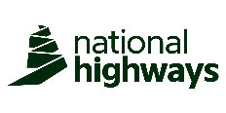




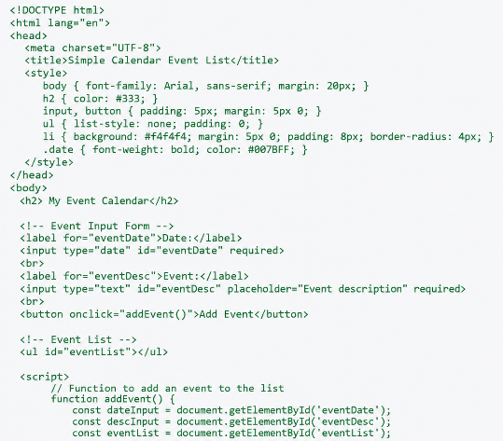



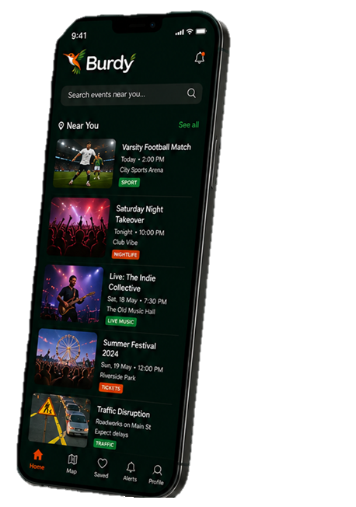


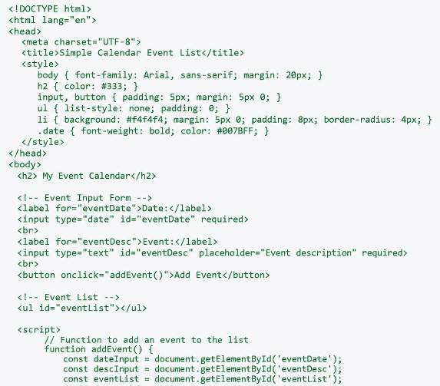
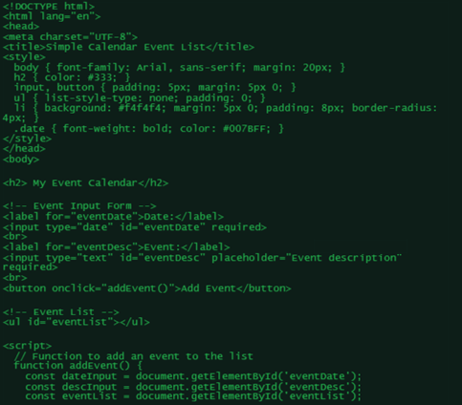
All the events, footfall drivers and local insights you need – in one powerful platform
Know what’s happening. Understand market demand. Optimise your rota. Maximise sales.
UNDERSTAND YOUR MARKET
Insights on footfall, spend potential and customer behaviour in your area
OPTIMISE ROTAS
Build smarter rotas with predictive footfall and event insights
INCREASE SALES
Know when demand is high so you can stock smarter, promote better and sell more
STAY AHEAD OF EVENTS
See what’s happening near you and plan with confidence.
TARGETED PROMOTIONS
Reach the right audience at the right time with event driven campaigns
GET THE BURDY ADVANTAGE
Use live customer data and trending socials to make your business smarter with real market insight
DEEPER INSIGHT.
MORE SALES.
DATA. DELIVERED.

SCAN HERE
CROSS MARKET PERFROMANCE
PRODUCT IMPACT
ALERTS AND NOTIFICATIONS
SMARTER ROTA PLANNING
REAL TIME MONITORING
DEMAND FORECASTING
BETTER ROTAS.
Burdy gives your business the real time edge.
LIVE INSIGHTS AND UPDATES
100+ CATEGORIES COVERED
50,000+ VENUES AND BUSINESSES
1,000,000+ EVENTS TRACKED
IN PARTNERSHIP WITH
KNOW MORE. PLAN BETTER. SELL MORE

